Drinking Water Service
Annual Report
Wellcamp Business Park Pty Ltd

SPID: 568

FY 2022-23

This report has been prepared in accordance with the Drinking Water Quality Management Plan Report Guidance Note.

Table of contents
1 Introduction 1
2 Summary of scheme/s operated 2
3 DWQMP implementation 3
4 Operational and verification monitoring - water quality information and summary 5
5 Incidents reported to the regulator 7
6 Customer complaints 8
7 DWQMP review outcomes 9
8 DWQMP audit findings 11

Table of tables
Table 1 – Risk management improvement program implementation status 4
Table 2 – Drinking water quality performance - verification monitoring 5
Table 3 – E. coli compliance with annual value 6
Table 4 – Incidents reported to the regulator 7
Table 5 – Example: customer complaints about water quality 8
Table 6 – DWQMP review outcomes 9
Table 7 – DWQMP audit findings and status 12

Introduction

This annual report documents the performance of the Wellcamp Business Park Pty Ltd (WBP) water supply as a water service provider with respect to its Drinking Water Quality Management Plan (DWQMP) for the financial year 2022-2023.

The goal of the DWQMP is the protection of the public health through the identification and minimisation of any public health related risks associated with drinking water.

This annual report assists the Regulator to determine whether the approved DWQMP and any conditions of approval have been complied with and provides a mechanism for providers to report publicly on their performance in managing drinking water quality.

This report includes a drinking water quality summary where drinking water across the WBP remained E.coli free during the financial year.

Summary of scheme/s operated

WBP receives drinking water from the Toowoomba Regional Council (TRC) bulk supply water main network. This water comes from TRC’s raw water storage reservoirs before being treated at Mt Kynoch water treatment plant. From Mt Kynoch the water is sent through the water main to a relatively new 8ML reservoir on Toowoomba-Cecil Plains Road/O’Mara’s Road, Charlton.

Drinking water for WBP is supplied from the Wellcamp Business Park’s water main. Currently it enters the site through a 150mm trunk main and is distributed via the 150mm distribution network.

Drinking water is supplied to the Wellcamp Airport terminal and to properties within the Business Park off the trunk main network.

With expected growth of WBP a storage reservoir will be installed on-site. This will help to supply the correct water pressure to the site for firefighting purposes. The underground pipe network will also expand from 13 km to a finished total of 14.6 km.

The water main network within WBP is now over seven (8) years old.

DWQMP implementation
The actions undertaken to implement the DWQMP are summarised below.
Water and Wastewater staff meet fortnightly to discuss any water/wastewater issues across the WBP. This provides the opportunity to refer to our approved DWQMP and emphasise the importance of using the plan. These meetings are organised and chaired by the Infrastructure Manager. Any new employees are made aware of our DWQMP through our WBP site induction process.

During the period, weekly sampling/testing of Free Chlorine and Turbidity around the WBP has occurred using the Hach DR300 and Turbidity test kits. These data results are recorded and graphed for trending and monitoring.
During the 22-23 financial year, our DWQMP undertook a review on the 18/05/23. Some of the major changes included the removal of 5 rows within the continuous improvement plan, given the completion of the items, as well as some basic formatting adjustments. No issues or major additions occurred as a part of this review.

The actions undertaken to implement the risk management improvement program are discussed in Table 2.

Table 1 – Risk management improvement program implementation status
Scheme name | Ref | Component | Improvement actions | Target date | Actions taken to date | Status and revised target date | Responsible Officer / Position

Operational and Verification monitoring - water quality information and summary
This section discusses the compliance with the water quality criteria.

Table 2 – Drinking water quality performance - verification monitoring
Scheme name | Parameter | No. of samples required to be collected (as per the approved DWQMP) | No. of samples actually collected and tested | Water quality criteria (i.e., ADWG health guideline value) | No. of non-compliant samples | Comments
WBP | E. coli | 1 per month | 12 | Less than 1 E. coli/100ml | 0
WBP | Free Chlorine | 3 per week | 145 | >0.2mg/L | 47 | Sites sampled are weekly at the Airport Terminal and randomly at two (2) other site.
WBP | THM’s | 3 Monthly | 9 | <250 μg/L | 1 | A non-compliant sample occurred on the 14/07/23. Subsequent testing occurred after this result.
WBP | Annual Metals | Annually | 0 | Aluminium 0.2 mg/L  Iron 0.3 mg/L  Manganese 0.5 mg/L / 0.1 mg/L  Na 180 mg/L  As 0.01 mg/L  Cd 0.002 mg/L  Cr 0.05 mg/L  Cu 2 mg/L / 1 mg/L  Ni 0.02 mg/L  Pb 0.01 mg/L  Zn 3 mg/L  Hg 0.001 mg/L | 0 | The annual metals sample was missed for the reporting period. A sample has been taken in November 2023, for the current financial year/period.
NOTE: See the below statistical analysis of the above three (3) parameters, over the reporting period (01/07/2022 – 30/06/2023).
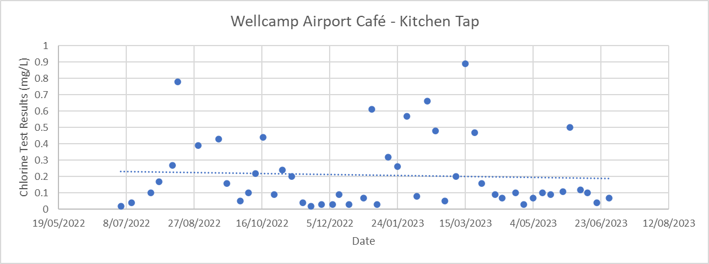
Chlorine Testing Results (2022-2023 FY)
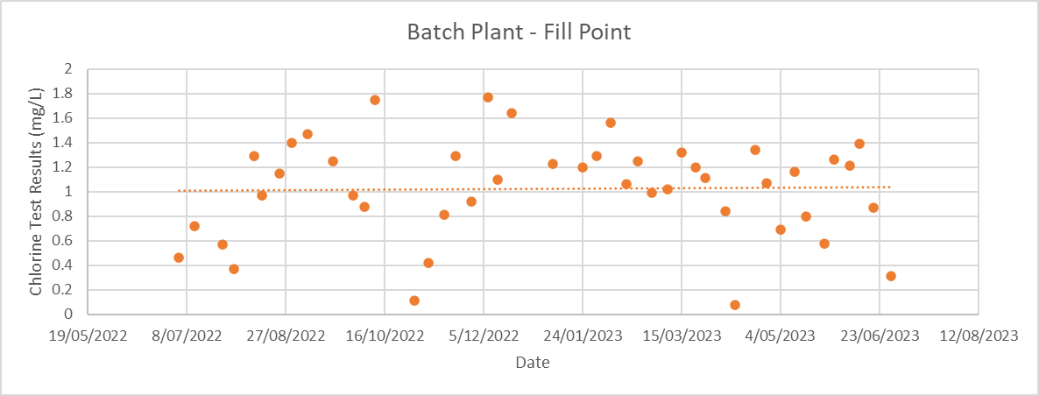
Average = 0.21 mg/L, Minimum = 0.02 mg/L, Maximum = 0.66 mg/L
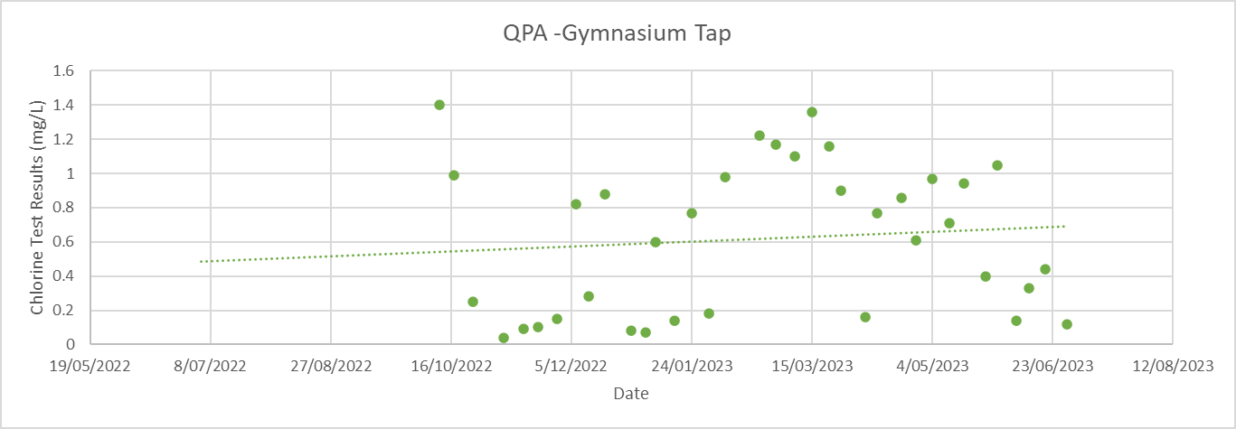
Average = 1.03 mg/L, Minimum = 0.08 mg/L, Maximum = 1.77mg/L
Average = 0.62 mg/L, Minimum = 0.04 mg/L, Maximum = 1.40 mg/

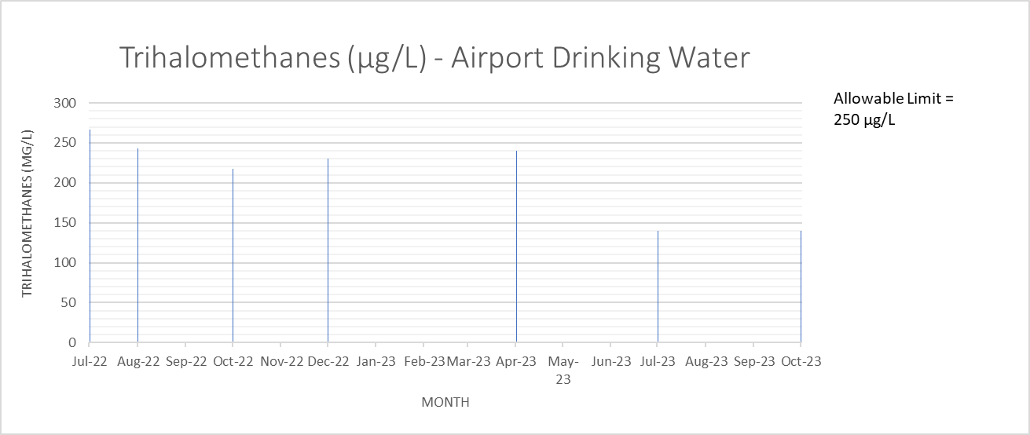
THM’s Testing Results (2022-2023 FY)
Average = 210 µg/L, Minimum = 140 µg/L, Maximum = 267 µg/L

Table 3 – E. coli compliance with annual value
Drinking water scheme: | WELLCAMP BUSINESS PARK PTY LTD
Year | 2022 – 2023
Month | July | Aug | Sept | Oct | Nov | Dec | Jan | Feb | Mar | Apr | May | Jun
No. of samples collected | 1 | 1 | 1 | 1 | 1 | 1 | 1 | 1 | 1 | 1 | 1 | 1
No. of samples collected in which E. coli is detected (i.e. a failure) | 0 | 0 | 0 | 0 | 0 | 0 | 0 | 0 | 0 | 0 | 0 | 0
No. of samples collected in previous 12-month period | 12 | 12 | 12 | 12 | 12 | 12 | 12 | 12 | 12 | 12 | 12 | 12
No. of failures for previous 12-month period | 0 | 0 | 0 | 0 | 0 | 0 | 0 | 0 | 0 | 0 | 0 | 0
% of samples that comply | 100.0% | 100.0% | 100.0% | 100.0% | 100.0% | 100.0% | 100.0% | 100.0% | 100.0% | 100.0% | 100.00  % | 100.0%
Compliance with 98% annual value | YES | YES | YES | YES | YES | YES | YES | YES | YES | YES | YES | YES

Incidents reported to the regulator.
The incidents reported to the regulator and management actions undertaken over the financial year are provided in this section.

Table 4 – Incidents reported to the regulator
Incident date | Scheme / location | Parameter / issue | Preventive actions
18/07/2022 | Wellcamp Business Park / Airport Café – Kitchen Tap | Exceedance of THM’s Allowable Limit. | Following thorough water mains flushing, Resampling, and monitoring occurred in the subsequent months, to ensure the THM’s level returned to within our allowable limits. THM’s continue to be tested quarterly, to ensure its effectively monitored. Results are now trended in a graph, to assist with recognising any patterns, that may lead to earlier detection.

Customer complaints
This section discusses details of any complaints received about the drinking water service
Refer to section 2.3.6 in the Guidance Note.
Table 5 – Example: customer complaints about water quality
Scheme | Health concern | Dirty water | Taste and odour | Other
WBP | 0 | 0 | 0 | -
Total | 0 | 0 | 0 | -

Nil Reported over this reporting period.

DWQMP review outcomes
Wellcamp Business Park conducted a site-specific risk assessment with the assistance of an external provider on the 11th February 2021, the replacement of the risk assessment within the DWQMP initiated a wider review of related aspects of the DWQMP. The review of the DWQMP was completed on the 9th March 2021, with the DWQMP then finalised, and the amended plan submitted to the Regulator on 18th March 2021.
Table 6 – DWQMP review outcomes
Review Date: 18/05/2023
Review component | Findings | Outcomes | Status of actions | Responsible Officer / Position
Service description | No changes | N/A | N/A | Infrastructure Manager
Details of infrastructure | No changes | N/A | N/A | Infrastructure Manager
Water quality and catchment characteristics | No changes | N/A | N/A | Infrastructure Manager
Risk assessment | No changes | N/A | N/A | Infrastructure Manager
Operations and maintenance procedures | No changes | N/A | N/A | Infrastructure Manager
Management of incidents and emergencies | No changes | N/A | N/A | Infrastructure Manager
Risk management improvement program | Five (5) improvement actions were removed, given their completion before the review. | The risk management improvement program has been revised. | RMIP has been updated | Infrastructure Manager
Service wide information management | Improvements across water sampling data management | Establish a process:  - to strengthen data filing in  the shared drive  - to undertake regular data  evaluation, for example,  transfer data from PDF  sheets into an Excel  spreadsheet for trending  - for the review and  approval process of  DWQMP Annual Reports | Occurring | Infrastructure Manager
Operational monitoring | No Changes | N/A | Occurring | Infrastructure Manager
Verification monitoring | No changes | N/A | Occurring | Infrastructure Manager

DWQMP audit findings
The audit findings and any recommendations and/or opportunities for improvement (OFI), including how these were actioned are discussed below.
No new/additional audit findings since external audit was undertaken by Viridus Consultants in October 2019.

The actions undertaken to address the audit recommendations are outlined in Table 8.
Table 7 – DWQMP audit findings and status
Item | Recommendation or OFI | Action | Status of actions | Responsible Officer / Position

